Project Proposal

“Trip Planner”

By

Arshdeep Kaur

Table of Contents

Project Proposal 2

Objectives 2

Project Description 3

Project Scope 4

Target Audience 5

Project Deliverables 5

Resource Requirements 6

Project Tasks 6

Assumptions of Project 6

Project Report 7

Detailed Design 8

Home Page 8

Login Page 8

My Trip Page 9

Detail of Trip 10

Testing 10

Summary 10

System Configuration 10

User Access Levels 10

# Project Proposal

## Objectives

The objective of the final project is to create a trip planner organisation system using C# Entity Framework. The website will be using ASP.NET MVC 5. The aim of the website is to make it simple for the user to manage and or create upcoming trips.

## Project Description

The aim of the website is to make it easier for the user to organise their upcoming trips in one place. The user can have multiple trips, with multiple flights and other categories. When a flight for example is created the Trip Id is saved.

The website allows the user to add multiple trips. Under a trip, the user can add flights, car rentals, other transportation, lodgings, activities and restaurant reservations to the trip. Each of these categories can have multiple items added to it. On the details page of the trip, the user can view their flights etc. according to date. The user can edit, and update each of the categories. If the user is wanting to delete an item, the website takes the user to the delete page and confirms if they want to delete the item or not.

The user can add a person under a flight or one of the other categories under the trip. To do this the user needs to go to the details of for example the flight. Then the user can click the link add person. By clicking this link, the Id of the flight is saved and is used when adding the person.

The website will look attractive and well labelled, so that the user can easily use it. The website has been made so that it is easy for them to add, edit, and delete a trip, flights etc.

Under each trip in the details page, the days that the user is away is displayed. Under each day, the flights etc. are displayed if the date is the same as the flight date for example. Under the flight, if the user has added any persons, they will be displayed here.

This project is using Entity Framework in C# using ASP.NET MVC 5. I am using SQLite for the database backend. The project will follow the CRUD system.

When I started the project I started with two database tables: Trip and Flight. Once I got these two tables working well, I added the Person Table. At first I called it Passenger, but after thinking about it, I decided to call it Person as then could be used with more than just the Flight table. After the three tables were working, I added the following tables: Lodging, CarRental, OtherTransportation, ActivityTask and Restaurant.

Each table has a primary key Id. The following had a foreign key of TripId: Flight, Lodging, CarRental, OtherTransportation, ActivityTask, Restaurant and Person. The Person has a foreign key for each of the tables apart from Trip. The foreign key helps to connect two tables together and means I can retrieve data from another table.

## Project Scope

The scope of this project is to implement an application named as “Trip Planner” with the help of which user able to organise their upcoming trips in one place. The duration of the project is 20 working days which is equals to 4 weeks. But I had completed this project within 3 weeks.

Project Specifications

* User can add multiple trips with multiple flights and categories.
* User can add flights, Car rental, other transporation, Lodgings, Activities, Restaurant reservation to trip.
* Each Categories have multiple items to add.
* User can view their flight.
* User can edit, and update each of the categories.

## Target Audience

The target audience for this project is People who are Planning for trip to anywhere. In this web application people can add their day to day activities and make the advance reservation.

## Project Deliverables

The deliverables for the project are written below:

* Planning of Project

This includes the research of project and find resoucres how to create database. As well as linking for tables.

* Coding

Under this, We are executing the code of the project.

* Designing

After Completion of coding designing is implement on the application to look attractive.

* Demonstration and Testing

In this functionality is checked of whole application that it meet all the requriments of client.

Testing is also done to check the all functions and buttons are working properly.

* Documentation Of Project

In last, Documentation is done to tell about the web application and detail about it.

## Resource Requirements

Following technologies and development method:

* Asp.net MVC Framework
* Identity framework- ASP
* Windows Operating System
* 64-bit processor and 8 GB or more RAM

## Project Tasks

## Assumptions of Project

Following are the assumption made while implementing the project:

* Anyone can register with the application.
* Application will be free and open source.

# Project Report

#### Functional and Non-Functional

**Functionality of Project**

* Login/logout
* Register new person
* user can add, edit, delete and check details of trip

#### **Non-Functionality of Project**

* High speed
* Fast Loading time
* High performance and security
* All browsers compatibility.

# Detailed Design

## Home Page

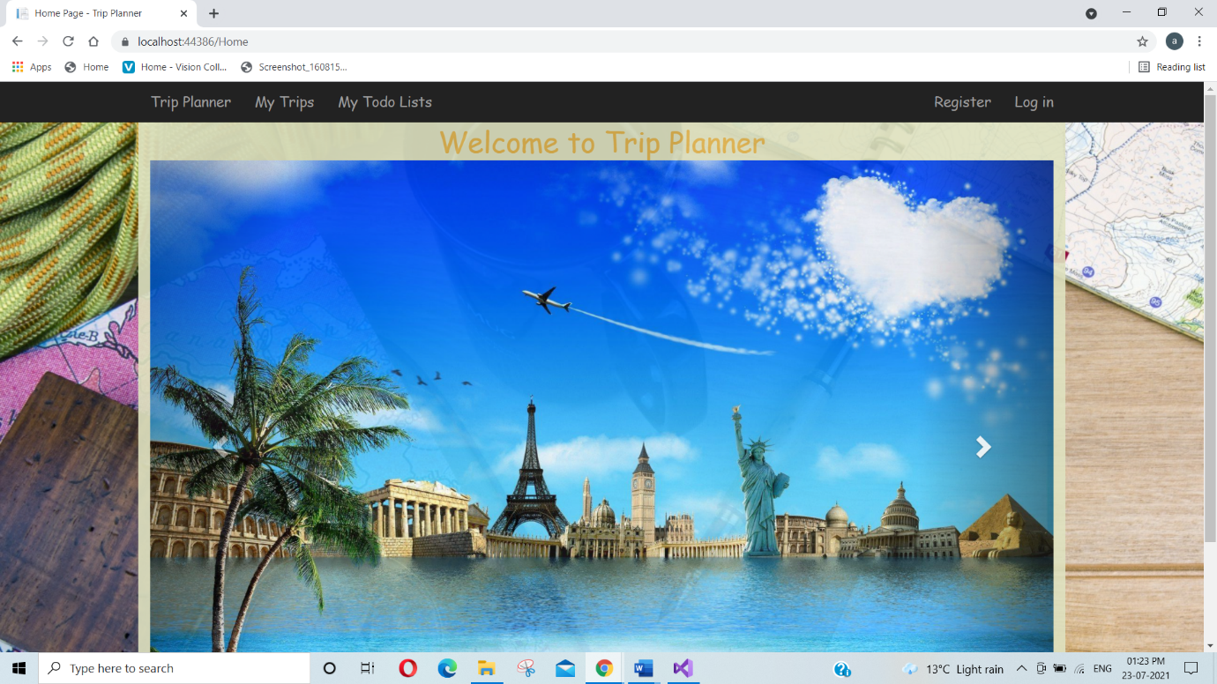This is the main page of the web application. This page contains Trip Planner, My Trip , My Todo, login, Register options on the navigation bar.

## Login Page

This Page will be used by the user to login into the system.

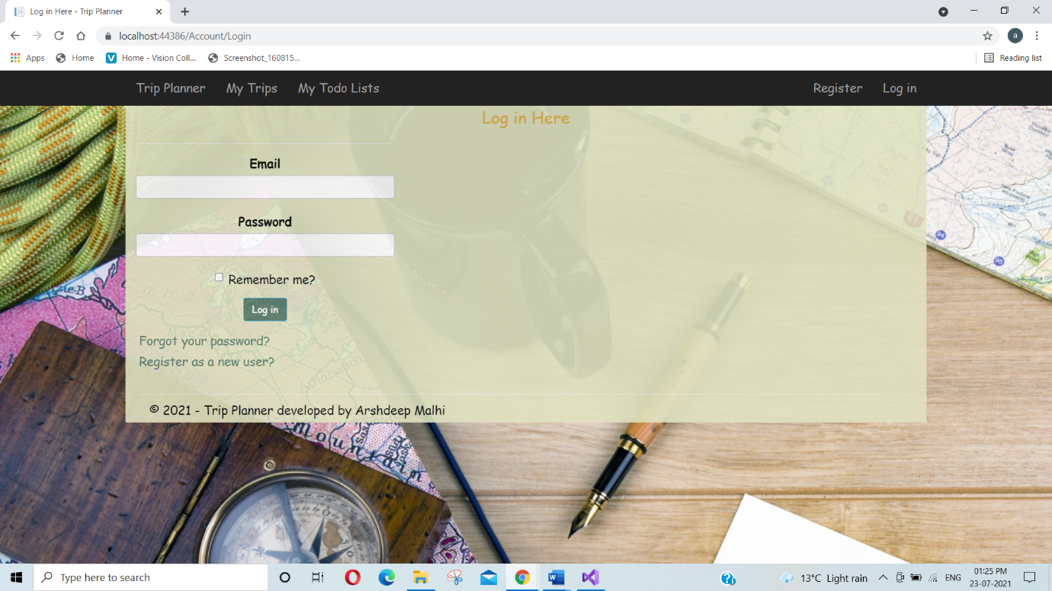

## My Trip Page

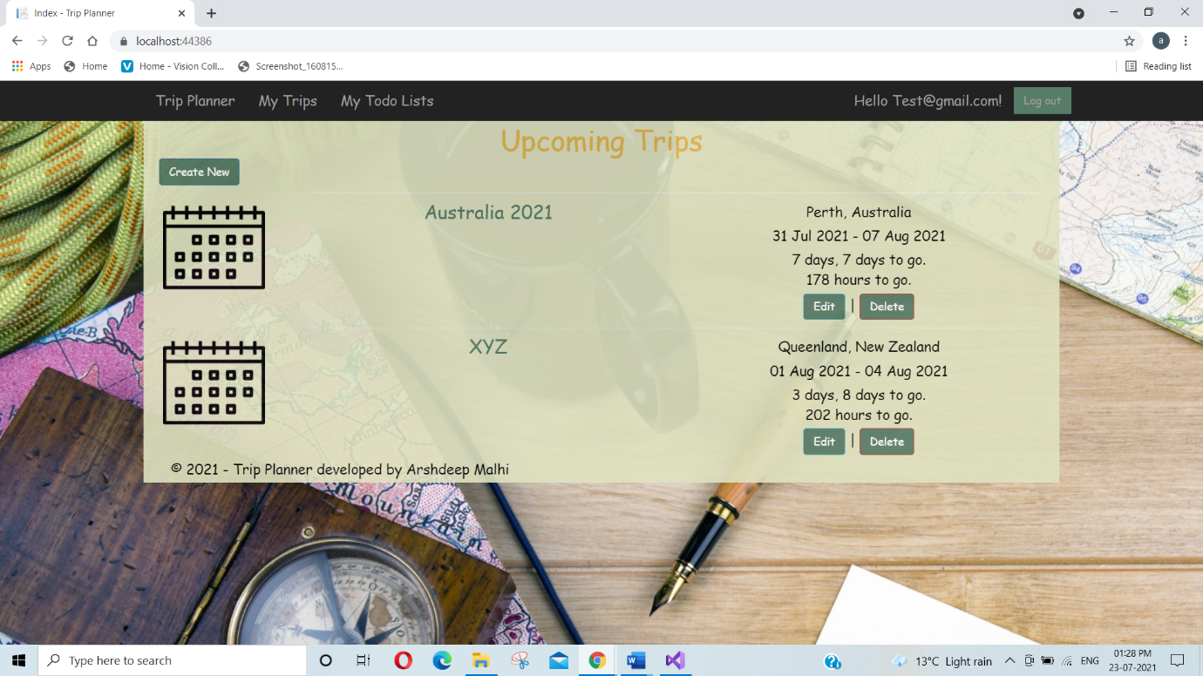Here all the trips which are added display here.

## Detail of Trip

## Testing

The testing file for usability testing is attached as usability test.xlsx

# Summary

### System Configuration

This app will be useful to for people who plan for Trip in advance.

### User Access Levels

Only registered users can access the features of this application.

**Registered Visitor:** New visitor can register and existing can login using their own credentials. They have limited access.